Dashboard Page

Definition
# Source: AI Source: Provided by: [Data Path: Persons Table -> ID Column: 1, Name_En Column: Motasem Essam] -> From: [Chatgpt (GPT‑5 Mini)] on [2/12/2026]
A Dashboard Page is a web page that provides users with a centralized overview of important information, data, or tools in one place, often in a visual and interactive format. It’s commonly used in web apps and admin panels.

Simple Definition
# Source: AI Source: Provided by: [Data Path: Persons Table -> ID Column: 1, Name_En Column: Motasem Essam] -> From: [Chatgpt (GPT‑5 Mini)] on [2/12/2026]
Dashboard Page = a page that shows key information and controls at a glance.

What a Dashboard Page Usually Includes
# Source: AI Source: Provided by: [Data Path: Persons Table -> ID Column: 1, Name_En Column: Motasem Essam] -> From: [Chatgpt (GPT‑5 Mini)] on [2/12/2026]
- Summary widgets / panels – quick stats or key metrics
- Graphs / Charts – visual data representation
- Recent activity / notifications – updates or alerts
- Navigation links – shortcuts to other sections or tools
- User controls – settings, profile, or management options

Purpose of a Dashboard Page
# Source: AI Source: Provided by: [Data Path: Persons Table -> ID Column: 1, Name_En Column: Motasem Essam] -> From: [Chatgpt (GPT‑5 Mini)] on [2/12/2026]
- Give users a clear overview of important data
- Help manage tasks, settings, or resources efficiently
- Make decision-making faster by showing visual insights
- Provide access to different features or tools from one page

Examples
# Source: AI Source: Provided by: [Data Path: Persons Table -> ID Column: 1, Name_En Column: Motasem Essam] -> From: [Chatgpt (GPT‑5 Mini)] on [2/12/2026]
- Admin panel → website traffic, user stats, content management
- E-commerce → sales reports, orders, and inventory
- Learning platform → course progress, scores, and upcoming lessons
- Banking app → account balances, transactions, and alerts

Difference Between Dashboard Page and Home Page
# Source: AI Source: Provided by: [Data Path: Persons Table -> ID Column: 1, Name_En Column: Motasem Essam] -> From: [Chatgpt (GPT‑5 Mini)] on [2/12/2026]
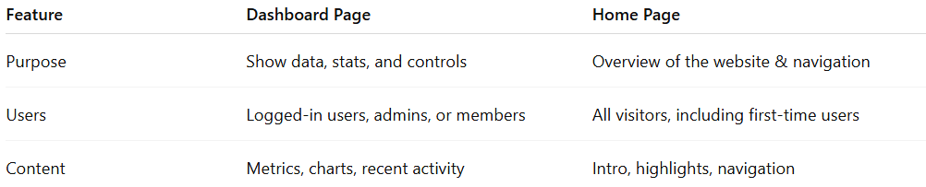
Feature | Dashboard Page | Home Page
Purpose | Show data, stats, and controls | Overview of the website & navigation
Users | Logged-in users, admins, or members | All visitors, including first-time users
Content | Metrics, charts, recent activity | Intro, highlights, navigation

